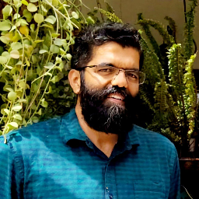 |  |  |  |  |  |  |  |  |  |  | Mahesh Sreekandath  System Software  San Jose, USA  maheshsreekandath@gmail.com
www.msreekan.com, medium.com/@jeanshack  Areas of Expertise  C  Linux Kernel  RTOS  Device Drivers  ARM  Python  Firmware  Cursor AI Tool  Amazon Web Services  Flash Storage Stacks  SQL  Storage Data Plane  Data Analytics  Automotive  Board Support Packages |  |  |  |  |  |  |  |  |  |  | Professional Summary  - System software engineer specializing in hardware-software co-design, firmware, device drivers, kernel, runtime optimization, and data-plane instrumentation spanning embedded to cloud environments.  - Inventor with patents in NAND write optimization (50%+ throughput gain on Samsung devices) and deterministic cloud latency (predictable I/O curve across millions of AWS EBS volumes).  - Proven expertise at profiling and re-architecting system bottlenecks from RTOS to large-scale distributed systems (Optimization Methodology Medium Post)  Employment History  Sr. Software Engineer, Google, Sunnyvale  August 2026 — Present  Sr. System Software Developer, NVIDIA, Santa Clara  February 2023 — August 2026  SDE, Amazon, San Jose  September 2017 — February 2023  Software Engineer, E Ink, San Jose  January 2017 — September 2017  Sr. System Software Developer, Blunk Microsystems, San Jose  November 2011 — January 2017  Priori Roles  March 2006 — August 2011  - Qualcomm (Sr. Engineer) (2010–2011)  - ST Ericsson (Tech Lead) (2009–2010)  - Freescale Semiconductor (Software Engineer) – (2007–2009)  - Mistral Solutions (Design Engineer) – (2006–2007)  Education  B. Tech in Computer Science and Engineering

